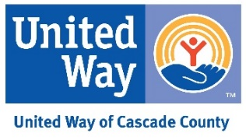
VOLUNTEER ENGAGEMENT FORM

Serving Cascade County

1900 32nd Ave NE, Black Eagle, MT 59414 PO Box 1343, Great Falls, MT 59403
406-727-3400 ext. 500  volunteer@uwccmt.org

Name _______________________________________________________________ Date_____________________________
Address____________________________________________________ City _________________________ Zip _________
Phone____________________________________ Email ___________________________________________________
Birth date ______________________ (You must be at least 55 years old to be a RSVP volunteer)
Gender Veteran Yes/No (Please circle one) Ethnicity __________________________
Preferred Volunteer Assignments/Interests/Skills
____________________________________________________________________________________________________________________________________________________________________________________________________________________________________________________________________________________________________________________________________________________________________________________________________________________________
Work/Volunteer Experience _______________________________________________________________________________________________________ _______________________________________________________________________________________________________
Days available: Mon _______ Tues _______ Wed_______ Thurs _______ Fri _______ Sat _______ Sun _______
Months not available ___________________________________________ Hours not available ______________________
Physical/Medical Limitations _______________________________________________________________________________________________________
RSVP Accident Insurance Beneficiary
Name_________________________________________________________________ Phone __________________________
Address ______________________________________________________________ Relationship _____________________
Emergency contact & number ____________________________________________________________________________

I verify that the above information is accurate to the best of my knowledge. I hereby volunteer my services through the United Way Retired and Senior Volunteer Program. If I use my car in volunteer service, I will keep in effect the minimum liability insurance. I understand there may be times during my volunteer service that the media may take pictures or film volunteers. If I do not want to appear in the media, it is my responsibility to decline an interview and/or move out of a camera shot.

Volunteer Signature _________________________________________________________

RSVP Staff Signature ________________________________________________________ Revised 5/2016

