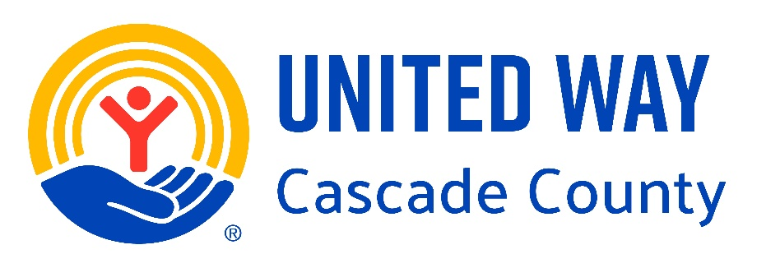

FY 2026 Request for Proposals
Guidelines

Dear Human Service Provider:

United Way of Cascade County (UWCC) is working to build a stronger community, creating opportunities for everyone by focusing on the following community-level outcomes:
- Youth Opportunity - Helping young people realize their full potential.
- Financial Security - Creating a stronger financial future for every generation.
- Healthy Community - Improving health and well-being for all.

For our 2026 Fiscal Year (July 2025 – June 2026) we are asking human service providers that align with our community goals to propose strategies to help us advance in these areas. Alignment with our stated goals and collaborative involvement with community level efforts are critical considerations of funding requests.

To be considered for funding, the program cannot discriminate based on race, color, religion, gender identity, sexual orientation, age, national origin, ancestry, physical or mental disability, marital status or other legally protected classes. (Those agencies with a religious affiliation wishing to receive funds must not refuse services to an applicant based on religion or require attendance at religious services as a condition of assistance, nor will such groups engage in any religious proselytizing in any program receiving United Way funds.)

Also, in response to significant increases in the costs associated with audits, financial reviews, and compilations we have amended our financial reporting requirements. Please reference the last page of these guidelines for the new policy. If you have any questions on this specific requirement, please contact Gary Owen at (406)727-3400 x8 or go@uwccmt.org.

The funding application contains the following:

Organization’s purpose and mission: your mission statement will suffice.

Section I – Values: explain your organization’s position on the following:
Collaboration – to ensure that scarce financial and human resources are used effectively, UWCC encourages collaboration among public and private human service providers. At a minimum, the program should be involved or working toward involvement in United Way’s corresponding community-level initiative, see last page of application for initiative information.

Reducing duplication - while the demand for human services in Cascade County is greater than the current system can meet, UWCC shares a community concern about the duplication of effort among service providers. UWCC volunteers will be proactive in their efforts to monitor duplication of effort and encourage providers to find ways to prevent unnecessary duplication.

Preventing root causes of issues - Programs that are preventive in nature will receive priority consideration, but we will continue to ensure that demands for basic needs in our community are met.

Section II – Brief program description: Provide a concise explanation of the program you are proposing for funding. This should be a very general overview, do not go into detail on any aspect.

Section III – Outcomes: (this is probably the most critical section of your application). Refer to the final page of the application and identify the primary community goal your program will advance. Note it in the format of Roman numeral/letter (for example IIC or IIIA, you don’t need to write it out).
Your program outcomes are the specific outcomes or goals you have for your clients/target population. The program outcomes must directly correlate to the primary community goal. Do not go into detail on how or why you set these outcomes, how you will achieve them, or even how you evaluate if you are reaching them – simply state your program outcomes or goals and clarify how it advances the identified primary community goal.

Section IV – Target Population: State who the program is trying to reach and why that population needs these services. Explain how and why you selected this particular demographic for the program to reach, this determination should be data-based. Note that United Way focuses on populations experiencing disparity – you will need to demonstrate how you determine eligibility.

Section V – Activities: Explain the activities the program will conduct to achieve the program outcomes referenced in section III. This section may further explain or define what was generically referenced in section II.

Section VI – Resources Needed: Describe the resources needed to conduct the program. We are not looking for minute details - list for example staffing levels, facilities, overall materials, equipment, etc.

Section VII – Outputs: Provide the actual numbers or goals for clients and numbers or goals for activity levels. So tell us how many people you expect to serve, how many “things” you will produce or provide and how many of the activities will be conducted. If this is an existing program, give historical data. For example: We plan on providing 6 classes this coming year and reaching 32 people; over the past three years we have averaged conducting 4 classes each year and averaged 30 individuals in each class. Be sure to give an unduplicated estimate or goal for individuals served.

Section VIII – Measures/Indicators: Describe how you determine if the program is achieving (or will achieve) the outcomes you listed in section III. List each program outcome from section III with a specific measure that makes sense in determining if the outcome is being achieved. If you use the same measure for different outcomes, still list each outcome from section III with a corresponding measure. The measure should make sense in that it demonstrates improvement in the stated outcome. If this is an existing program, give historical data.

Included in the application, is a 5 question “one pager”. This document is self-explanatory and is intended to give a simple narrative of the program for which you are applying for funding so that our Grant Review volunteers can easily understand and follow.

Process
A mandatory training workshop on the application process will be held on Tuesday, March 4, 2025 from 9:30am – 11:30am at Montana Credit Union, 15 14th St S. Your organization must have a representative present to be eligible to apply for funding. The last 30 minutes of this workshop will feature a mock presentation designed specifically to help new programs interested in applying. If a representative is not present for the first 90 minutes of the training, the organization will not be considered for funding.

All applications for UWCC funding for Fiscal Year 2026 must be submitted by email to go@uwccmt.org no later than 5:00 p.m. on April 3, 2025. Supporting documents may be emailed or hard copies mailed to UWCC PO Box 1343 Great Falls, MT 59403.

Applicants will receive preliminary scores, feedback and questions by April 23 and will have until April 29 to provide written responses.

Grant Review Committee volunteers will be assigned to subcommittees and will hear presentations from agency representatives on May 6 or 7. The full Grant Review Committee will meet the following week to determine funding recommendations.

The recommendations will be heard and considered by the UWCC Board of Directors at its May 15, 2025, meeting. Funding decisions will be communicated to applying agencies by 5:00 PM on May 23, 2025. Disbursement of funds for Fiscal Year 2026 will be made monthly beginning July 1, 2025.

Applicants should note that UWCC has not historically supported 100% of program or agency budgets. UWCC funding often leverages other agency resources. All funding decisions will be based, in part, on several criteria:
- Validity and value of program outcomes and measures.
- Alignment with desired community goals.
- Resources required to achieve the desired outcomes.
- Capacity of the applicant to implement service strategies.
- Availability of funds.
UWCC generally supports the costs of service delivery to achieve the stated outcomes including personnel, supplies, and necessary overhead/administrative expenses. Because funds are limited, requests for capital expenditures such as equipment, vehicles, and facility purchase, or renovation are discouraged. UWCC will not make direct contributions to endowments or reserve funds.

All organizations receiving funding from UWCC are required to report progress. The schedule for these reports and a standard form with instructions will be provided with the notice of funding approval. In addition to the written reports, each funded service may be asked to meet with a panel of grant volunteers to review progress. These meetings are intended to provide assistance in meeting United Way requirements and to help fully utilize outcomes.

NOTE: each funded service is a critical partner in helping United Way strengthen our community. Community-level initiatives have been formed around each community goal. Funded services will be expected to participate and help advance the work of the appropriate initiative. We also ask that funded services provide the opportunity for their staff, board of directors, and volunteers to participate in the United Way Annual Campaign.

CHECKLIST - the following must be included in your proposal:

- Completed FY 2026 RFP Application
- Completed “one pager”
- IRS letter of determination
- List of Board of Directors with contact information
- Most recent financial statements (monthly/quarterly balance sheet and income/expense statement)
- Most recent audit (or document complying with policy on page 5 of these guidelines)
Documents other than the application and one-pager may be provided in hard copy if not available electronically.

Please note the following dates (all 2025):
- March 4 – mandatory training workshop (9:30 – 11:30am, MT Credit Union, 15 14th St S)
- April 3 – proposals due to United Way by email, no later than 5:00pm.
- April 23 – preliminary scoring, comments and questions from volunteers forwarded.
- April 29 – written responses to feedback/questions due no later than 5:00pm.
- May 6 or 7 – Presentations to volunteers (30 min slots, MT Credit Union, 15 14th St S).
- May 23 – funding decision communicated to applicants via email.
- July 1 – monthly disbursement of funds begins.

Questions? If you have any questions, please call Gary Owen at (406)727-3400 x8 or email go@uwccmt.org.
Financial Statement Policy for Funded Services

All service providers that request a grant from United Way of Cascade County must comply with the Financial Statement Policy as follows.
- Total revenues of less than $200,000 – a form 990 or 990-EZ must be submitted.
- Total revenues of $200,000 and above – a form 990 must be submitted.

In addition, if you have:
- Total revenues of $500,000 – less than $1million – Compiled financial statements by an independent certified or licensed accountant must be submitted.
- Total revenues of $1million – less than $2million – a review or audit performed by a certified public accountant must be submitted.
- Total revenues of $2million or more – an audit performed by a certified public accountant must be submitted.

Exemptions from this policy will be given only to funded services under the direct sponsorship of a governmental unit and which are included in the audit of that governmental unit.

If a funded service changes its fiscal year in order to coincide with United Way’s fiscal year or that of a major funding source, a compilation as specified above for the short year plus the 12 months prior to the start of the short year will be accepted.

